**WINDOW FUNCTION QUESTIONS**

The Sales table structure is as follows:

CREATE TABLE Sales1 (

    SaleID INT,

    SaleDate DATE,

    CustomerID INT,

    ProductID INT,

    Amount DECIMAL(10, 2)

);

INSERT INTO Sales1 (SaleID, SaleDate, CustomerID, ProductID, Amount) VALUES

(1, '2024-01-01', 101, 1001, 150.00),

(2, '2024-01-02', 102, 1002, 200.00),

(3, '2024-01-03', 101, 1001, 100.00),

(4, '2024-01-04', 103, 1003, 300.00),

(5, '2024-01-05', 102, 1002, 250.00),

(6, '2024-01-06', 101, 1001, 175.00),

(7, '2024-01-07', 104, 1004, 400.00),

(8, '2024-01-08', 105, 1005, 350.00),

(9, '2024-01-09', 102, 1002, 225.00),

(10, '2024-01-10', 101, 1001, 125.00);

select * from Sales1;

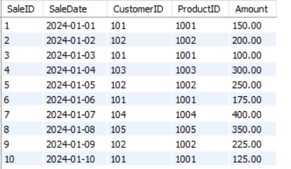

**Question 1: Calculate the running total of sales amount.**

select SaleID,ProductID,SaleDate,sum(Amount) over (order by SaleDate) as "Total Sales Amount" from Sales1;

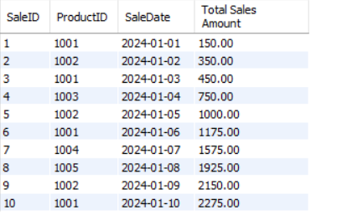

**Question 2: Calculate the average sales amount over the last 3 sales.**

select SaleID,SaleDate,CustomerID,avg(Amount) over (partition by SaleDate rows between 2 preceding and current row) as "Avg last 3 sales" from Sales1;

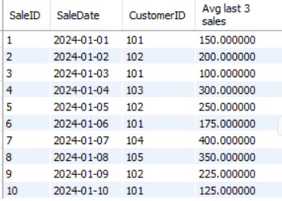

**Question 3: Rank the sales by amount for each customer.**

select SaleID,SaleDate,CustomerID,Amount ,rank() over (partition by customerID order by Amount desc) as "Rank By Amount" from Sales1;

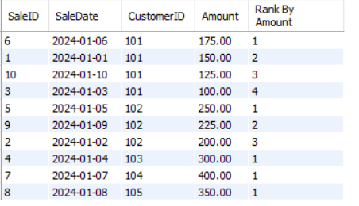

**Question 4: Calculate the cumulative distribution of sales amount.**

select SaleID,SaleDate,Amount ,cume_dist() over (order by Amount) as "Cumulative distribution " from Sales1;

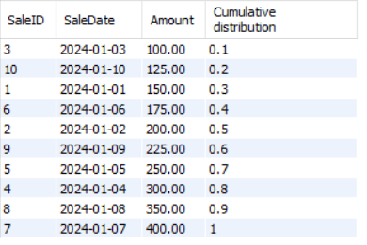

**Question 5: Calculate the difference in sales amount between the current sale and the previous sale.**

select SaleID,SaleDate,Amount ,Amount-lag(Amount,1) over ( order by SaleDate) as "Amount Difference" from Sales1;

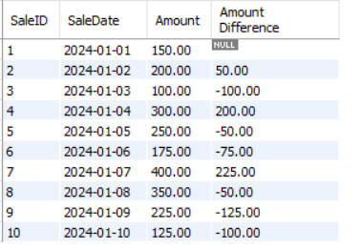

**Question 6: Calculate the lead sales amount for the next sale.**

select SaleID,SaleDate,Amount,lead(Amount) over ( order by SaleDate) as "Lead sales" from Sales1;

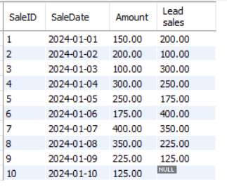

**Question 7: Find the first sale amount for each customer.**

select SaleID, CustomerID,SaleDate,Amount,first_value(Amount) over (partition by CustomerID order by SaleDate) as "First sales Amount" from Sales1;

